H.T No
Regulations:
A15


Sreenidhi Institute of Science and Technology
(An Autonomous Institution)
Code No: 5B414 Date: 01-Dec-2018 (AN)

B.Tech II-Year II-Semester External Examination, Nov/Dec - 2018 (Supplementary)
Machine Drawing and computer aided design (ME)

Time: 3 Hours Max.Marks:75

Note: a) No additional answer sheets will be provided.
b) All sub-parts of a question must be answered at one place only, otherwise it will not be valued.
c) Missing data can be assumed suitably.

Part - A Max.Marks:30

ANSWER ANY TWO QUESTIONS. EACH QUESTION CARRIES 15 MARKS.

1. | Draw the conventions for the following:  (i)Glass (ii)Rubber (iii)Steel (iv) Wood (v)Concrete | [15M]
2. | Draw the sectional front view and top view of a double riveted (zig-zag type) lap joint. Take the thickness of plate as 10 mm. | [15M]
3. | Draw the sectional front view and side view of a cotter Joint with suitable proportions. | [15M]

Part – B Max.Marks:45
Part-B (is Compulsory 45 Marks)

4. |  | Assemble the parts of an eccentric shown in Fig.1 below and draw the Half -sectional front view with upper half in section and right side view. Table 1 below gives the details of the parts.  Table.1  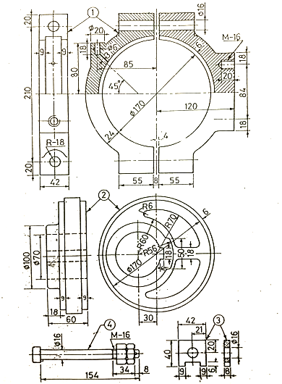
  Part No. | Name of Part | Quantity | Material
  1 | Straps | 1+1 | C.I.
  2 | Sheave | 1 | C.I.
  3 | Shim | 2 | Brass
  4 | Bolts with Nuts | 2 | C-30
-- 00 -- 00 –

